SPL2 Project Proposal Form, 2024
Institute of Information Technology (IIT)
University of Dhaka

Student’s Name: | Abdus Salam Islam Badhon, Md Nahidur Rahman Nahid
Student’s Roll: | 1401, 1429 | Phone: | 01305085443, 01635222390
Project Title: TimeWise: Time and productivity management

Motivation: A study by McKinsey found that efficient time management boosts productivity by 25%. Also a research by Gloria Mark (University of California, Irvine) reveals that frequent task-switching reduces productivity, with interruptions occurring every 3 minutes.TimeWise aims to address these issues by helping users focus, reduce distractions,manage time and improve task management.

Project Description: TimeWise is a Progressive Web APP(PWA) designed to enhance productivity through efficient time and task management.It will have different features like the following:

Normal Features:
1. User management: Managing user’s accounts for personalized experience along with authentication and authorization.
2. To-Do Lists: Organize daily tasks and small activities for achieving daily goals. Like breaking down the goal of learning a technology to some chunks of tasks.
3. Progress Tracking: Users can set high-level goals based on specific categories, such as learning a new language, mastering a technology.Users can maintain progress toward goals with real-time tracking.
4. Reminders & Notifications: Sends timely reminders to keep users on track with their plans.User can set customizable reminders.
5. Showing Stats: Users will be able to see relevant statistics about his/her performance and participation.
6. Performance Tracking: Users can track their performance and make necessary adjustments to improve productivity.

Exciting Features:
1. Deep work tracking : Users will be able to see in which time span users can perform better.
2. Collaborative and competitive environment: Users will be able to share their goals and plans with others. They can evaluate their performance with respect to others.
Strategy & Timeline: Our strategy is to break down the project into distinct components and develop the independent parts concurrently. For the interconnected modules, we'll employ a collaborative strategy, using pair programming to ensure smooth integration and mutual problem-solving. Both of us will participate in development of the frontend and backend part.

Gantt Chart of timeline of activities:

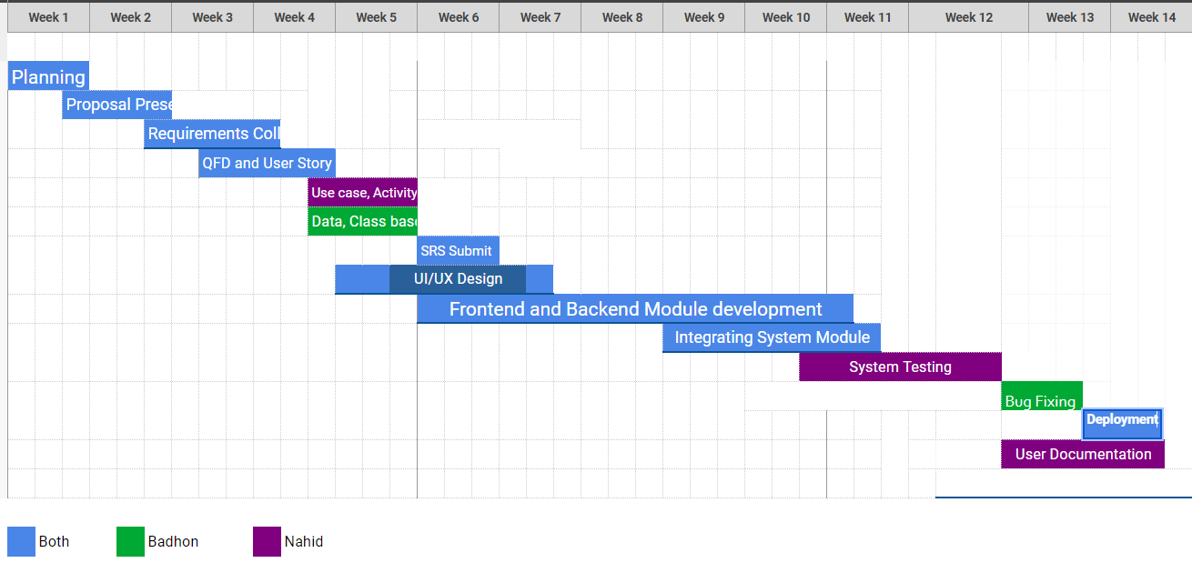

Languages or Tools to be used: Spring Boot, MongoDB, Next js, Selenium, Postman, Github, Docker

Supervisor’s Name: Mridha Md. Nafis Fuad
Signature of the supervisor:_________________________
Date: _____________________

References:
1)McKinsey Productivity Report:https://tinyurl.com/bddc2s7t
2)Gloria Mark's 2023 book, Attention Span: A Groundbreaking Way to Restore Balance, Happiness, and Productivity

Before the Midterm Presentation 1:
I confirm that the progress is satisfactory and I am forwarding it for midterm presentation.
Signature of the supervisor:_________________________
Date: ________________________

Proposal Presentation Feedback (if any) :

Midterm 1 Presentation Feedback (if any) :

Midterm 2 Presentation Feedback (if any) :

